Kevin Nunez 00323217 Linux Administration Adrianna Holden Gouveia Server Security 10/31/2026
Instructions:
In this assignment we have access to AI tool, with this AI tool you need to create a script that follows the next requirements.
Your prompt must ask for a script that meets all these script requirements:
• It runs on both of your servers without any changes.
• It reports failed SSH logins from the last 24 hours.
• It lists all accounts with root privileges (UID 0) and any accounts with
empty passwords.
• It lists listening ports using ss.
• It saves its results to a timestamped file in a directory you choose, not
in /tmp.
• It works when run from cron.
• It does not install anything or change any system settings.
• It exits with a non-zero exit code if it finds a problem.

Questions:
What was the prompt you gave it?
I say to the AI tool to please create a script for CentOS and Ubuntu, a script that can run in both server without bugs and errors, I specified all the requirements above for creating the script.
What changes did you have to make to the script for it to work?
In the first time the script that make Copilot works without error, the script is running in both servers with no errors.
In the case of Gemini, is different in the CentOS server, the original prompt Server-Security.sh works without problems, but in Ubuntu the error date: invalid date appears and the script didn’t work, so in this case I replace section 1 of the code.
"date -d \"" $1 " " $2 " " $3 "\" +%s" | getline ts_log
CentOS and older Ubuntu systems log timestamps using the traditional System log format (example, Oct 31 12:00:00). The GNU date utility reads this perfectly.
Modern Ubuntu systems use the strict ISO 8601 format for system logs (example, 2026-10-31T12:00:00.123456+00:00).
The Error is because of the spaces and complex symbols inside that specific ISO string, feeding it into date -d inside an awk loop completely broke the syntax, flooding my terminal with the date: invalid date messages.

The Fix of this problem:
To fix it natively without introducing multi-platform parsing issues, we bypassed raw log file scraping entirely and implemented Systemd's native journal mechanism.
This is the exact snippet that makes the script work perfectly on both servers.

# Use journalctl to fetch sshd logs from the last 24 hours across both OS natively.
# This avoids 'invalid date' parsing errors caused by different OS log styles.
if command -v journalctl >/dev/null 2>&1; then
journalctl _SYSTEMD_UNIT=ssh.service _SYSTEMD_UNIT=sshd.service --since "24 hours ago" 2>/dev/null | grep -E "Failed|Invalid user" > /tmp/ssh_failed_temp.txt
else
# Fallback for older systems without systemd/journalctl
if [ -f /var/log/secure ]; then AUTH_LOG="/var/log/secure"; else AUTH_LOG="/var/log/auth.log"; fi
grep -E "Failed|Invalid user" "$AUTH_LOG" 2>/dev/null | grep -v "cron" > /tmp/ssh_failed_temp.txt
fi
Why this specific snippet work:
journalctl abstraction: Both modern CentOS and Ubuntu utilize systemd. journalctl talks directly to the system kernel database, meaning it tracks timestamps internally.
--since "24 hours ago": Instead of letting Bash or Awk calculate the math, journalctl handles the time calculation flawlessly regardless of how the system renders textual logs.
Distribution Agnostic: It looks for both ssh.service (Ubuntu naming convention) and sshd.service (CentOS naming convention) simultaneously, matching the requirements seamlessly.
What changes did you have to make to the prompt?
I added some comments, and I say to the tool some other changes to the script. I also need to change the code of the script to when the script run shows me the complete file in the terminal like how it looks in the file log, for this I change the code from:
} > "$REPORT_FILE" to } | tee "$REPORT_FILE"
With this change I can see the log in my terminal too.
How many tries did it take to get something that worked?
I use two tries, one for the original script that runs in CentOS but not in Ubuntu, so I make a change that works in Ubuntu.
Describe the whole conversation with the AI including all modifications and you’re testing on the servers.
I say to the AI to make the script, and the second change to make, I ask the AI how to convert a windows .txt file to a .sh file that can run in CentOs and Ubuntu, when I create the script I think it can be fast if I make the script ad then with the SmarTTY send the file to each server, but this files can’t be execute in Linux, so we need to convert the file from .txt to .sh file in the Linux system, and give them permissions, and convert the file to a Linux reader with the tool dos2unix (FileName), with this we convert the file and now can be executed in Linux.
My Github: https://github.com/kevinNunez137/Linux-Administration

CentOS-Gemini
The first step that I took in this assignment was to make the file Server-Security.txt in my host computer.
I opened SmarTTY to send the file to the CentOS server, after this step I used the command mv to rename the file to make the file executable, so I changed the name to Server-Security.sh
After running this command, I check if the file is correctly changed and in order.
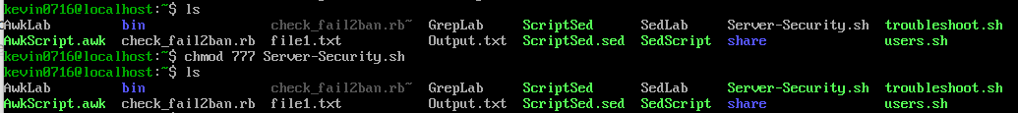
With the tools dos2unix, I change the windows format to a Linux format for executable.
If you don’t have the tool, you can install the tool with the command sudo install dos2unix.
I run the command dos2unix Server-Security.sh

After that I run the command sudo ./Server-Security.sh
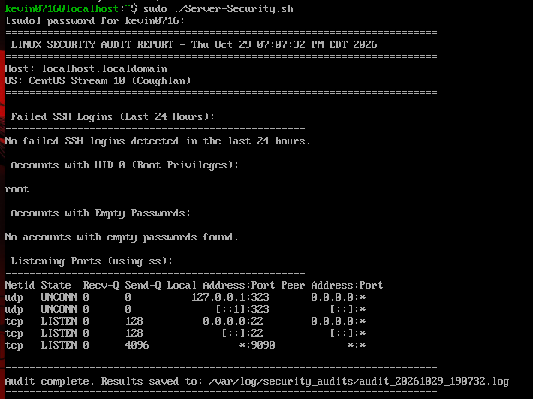
How you can see the file log goes to /var/log/security_audits/”unique file name”.log

CentOs-Copilot
Here I did the same but with a different file name, in this case I changed from mv Server-Security-Copilot.txt Server-Security-Copilot.sh
Now with dos2unix Server-Security-Copilot.sh to change to the Linux format.
Here I run the command sudo ./Server-Security-Copilot.sh for executing the script
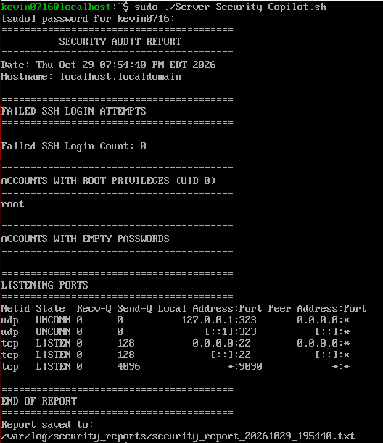
The log file is in /var/log/security_reports/”unique file name”.txt
Write a paragraph or two explaining if there is anything else you think you should have a script and/or cron job for relating to security. Why or why not?
Cron Job
Using cron to run security scripts automatically is very important to keep Linux servers safe. My script checks for failed logins, root users, and open ports by reading files like /etc/passwd, /etc/shadow, and using the ss command. However, in real servers, administrators use cron to run more advanced tools too. For example, they schedule tools like Lynis or Rootkit Hunter https://cisofy.com/documentation/lynis/ (RKHunter) to scan the system files and look for malware, hidden rootkits, or bad configurations every night. Also, many systems use a tool named fail2ban alongside these audit scripts; fail2ban https://www.redhat.com/en/blog/protect-systems-fail2ban reads the logs automatically and blocks the IP addresses of hackers who try to guess passwords. Another common job for cron is running automatic updates for critical security patches using packages like unattended-upgrades on Ubuntu https://ubuntu.com/server/docs/how-to/software/automatic-updates/ . All these automated scripts help protect the server 24/7 so a human admin does not have to type commands manually every hour. I don’t need to make too many changes, because the script I write with the AI is very complete and doesn’t need too much, because the little change I made is not for making cron work with more ads, the scripts work well.
If I need to run a cron job in this two script I will the cron 0 1 * * * /usr/local/bin/Server-security.sh > /dev/null 2>&1. And 0 1 * * * /usr/local/bin/Server-security-Copilot.sh > /dev/null 2>&1, this configuration is daily because these types of failures like full storage, infinity logs, wrong applications, or permission change can occur in daily production. Executing at 1:00 AM ( 01 **) is better for the charge of the server, minimizing the impact of the production.

Server-Security2.sh Script
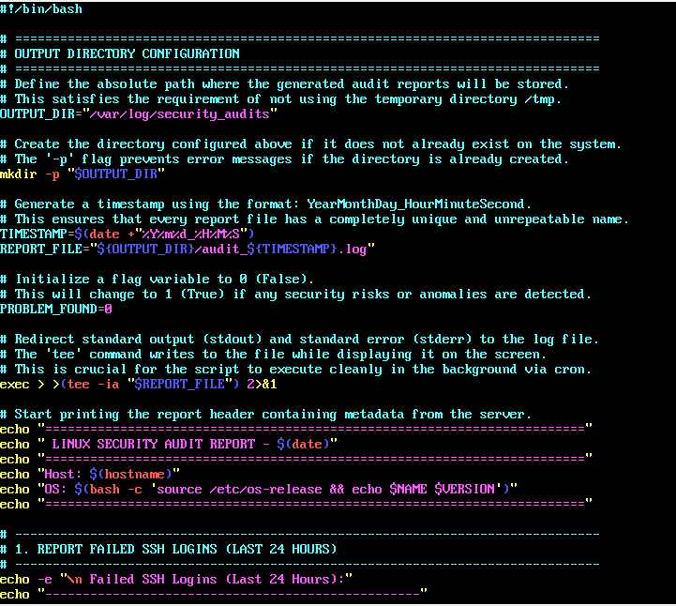

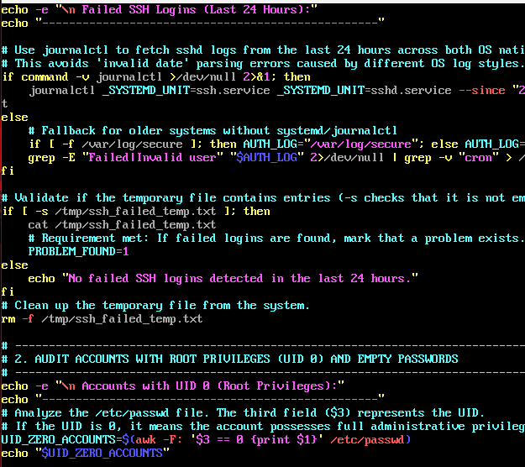
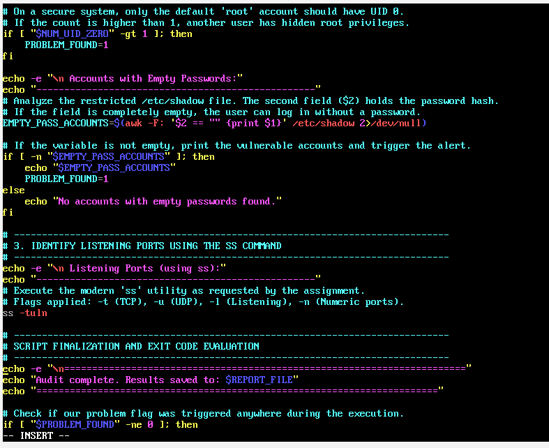
Directory Setup: It defines a secure path (/var/log/security_audits) to store reports and automatically creates it if it doesn't exist. This is important requirement that we need because we need a path for our log files. https://www.redhat.com/en/blog/create-delete-files-directories-linux
Log File Creation: It generates a unique filename using a detailed timestamp Year/Month/Day and Hour/Minute/Second so that older reports are never overwritten. And create a unique log file. https://docs.redhat.com/en/documentation/red_hat_enterprise_linux/7/html/system_administrators_guide/ch-viewing_and_managing_log_files
Alert Control: It initializes a flag variable (PROBLEM_FOUND=0) that acts as a switch to indicate if any security risks are detected later on. https://docs.redhat.com/en/documentation/red_hat_enterprise_linux/7/html/system_administrators_guide/ch-viewing_and_managing_log_files
Output Redirection (exec > >(tee ...) 2>&1): It configures the script so that everything printed on the screen is simultaneously saved into the .log file. This is crucial for running cleanly in the background via cron so this can run automatic. https://www.geeksforgeeks.org/linux-unix/input-output-redirection-in-linux/
Report Header: It prints basic server metadata to identify the report, including the current date, the system's hostname, and the exact OS version. https://www.serveracademy.com/blog/linux-head-command
Audit Initialization: It sets up the first analytical section of the report to inspect and display failed SSH login attempts over the last 24 hours. https://www.redhat.com/en/blog/configure-linux-auditing-auditd
Modern SSH Log Extraction (journalctl): It checks if journalctl is available on the system. If it is, it uses it to query systemd directly for ssh or sshd daemon logs over the last 24 hours. https://socprime.com/blog/where-to-find-ssh-sshd-logs-on-linux-and-how-to-export-them/
Legacy SSH Log Fallback: If journalctl isn't available, it falls back to inspecting traditional plaintext log files (/var/log/secure or /var/log/auth.log), pulling lines containing "Failed" or "Invalid user" while ignoring cron traffic. https://socprime.com/blog/where-to-find-ssh-sshd-logs-on-linux-and-how-to-export-them/
Alert Triggering: It saves these failed login attempts into a temporary file. If the file is not empty (-s check), it prints the attempts onto the screen (which logs them via the previous redirection) and toggles the alert switch to PROBLEM_FOUND=1. The temporary file is then cleaned up. https://virima.com/features/cmdb?utm_source=google&utm_campaign=GoogleAdsVirimaDTR&gad_source=1&gad_campaignid=14576577965&gbraid=0AAAAADvvKwcccR5uF4jzF60TBp8Zg8HQU&gclid=EAIaIQobChMIiML0leWCmAMVFSlECB2DZRiWEAAYASAAEgIGJ_D_BwE
Root Account Discovery: It transitions to section 2, scanning the system configuration file (/etc/passwd) using awk. It extracts and lists every username that has a User ID (UID) of 0, highlighting any accounts that possess full administrative root privileges. https://www.redhat.com/en/blog/linux-superuser-access
Rogue Root Detection: It evaluates the number of accounts found with UID 0. On a standard security system, only the default "root" account should have this ID; if the count is greater than 1, it triggers an alert (PROBLEM_FOUND=1). https://docs.redhat.com/en/documentation/red_hat_enterprise_linux/7/html/security_guide/sec-controlling_root_access
Empty Password Check: It scans the protected /etc/shadow file using awk to see if the password field (the second column) is completely empty. If it finds any password less accounts, it prints their usernames and flags the script with an alert. https://www.redhat.com/en/blog/managing-users-passwd
Network Port Mapping (Section 3): It executes the modern socket statistics utility (ss -tuln) to inspect active network configurations. This instantly prints all open, listening to TCP (-t) and UDP (-u) ports using numeric values (-n) instead of resolving service names. https://www.redhat.com/en/engage/linux-system-management-ebook?sc_cid=RHCTN0260000492927&gclsrc=aw.ds&gad_source=1&gad_campaignid=20497751743&gbraid=0AAAAADsbVMQ-wWLw9m227rEvXM49TxkbP&gclid=Cj0KCQiA5NXXBhDEARIsABAJhdJuTBzLEZwAZh0ndgob1eYMTaiKcgdsuMMcrtfj5UEQvIOv9ai5aqIaAn7bEALw_wcB
Script Finalization: It prints a concluding message to notify the operator that the audit is complete and confirms the path to the saved $REPORT_FILE. It then begins a final conditional check on the $PROBLEM_FOUND flag to determine the exit status (though the text cuts off mid-command).

Server-Security-Copilot.sh Script
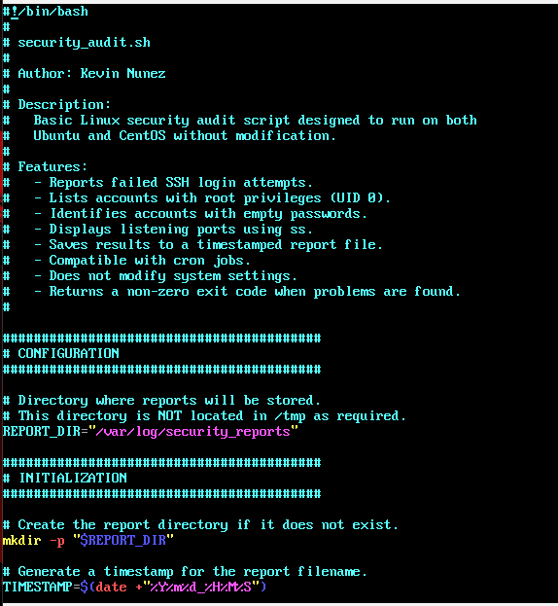
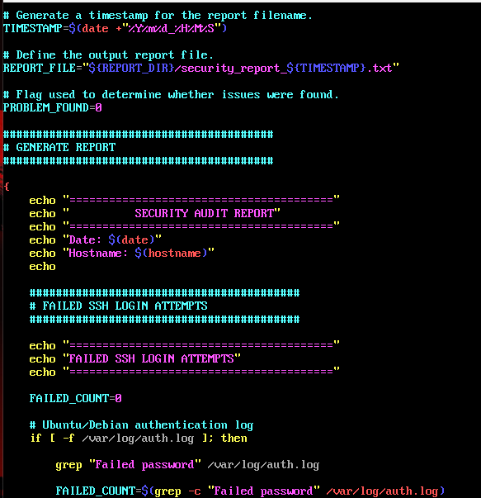
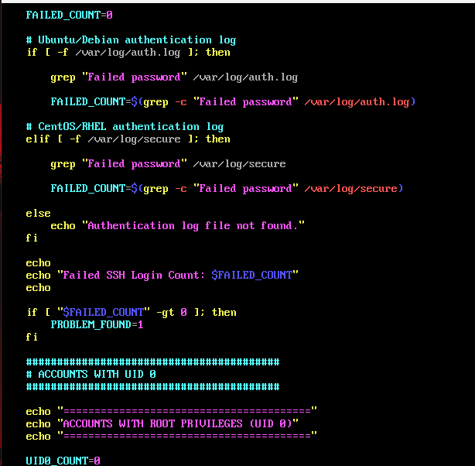
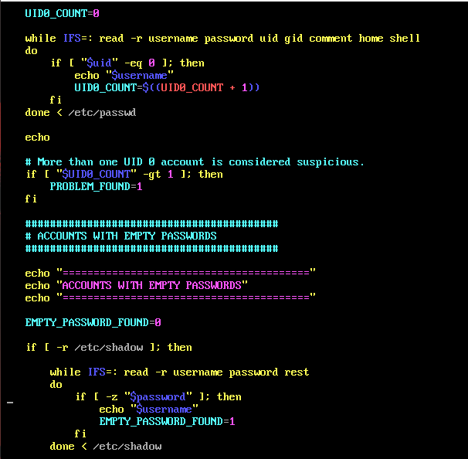
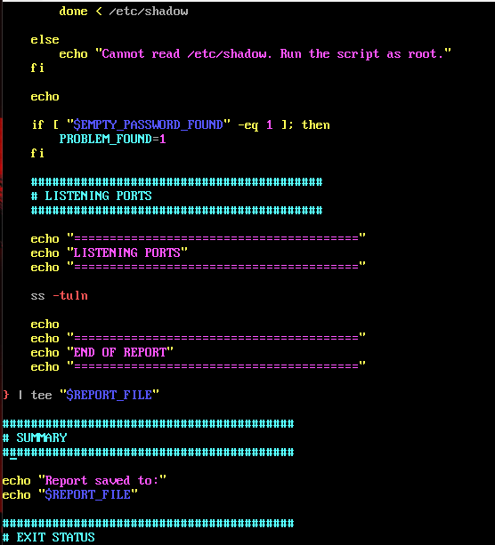

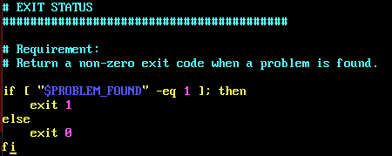
Script Documentation: It defines the script metadata, stating that security_audit.sh is built to run seamlessly on both Ubuntu and CentOS (RHEL-based) systems without changes.
Output Path Configuration: It sets up a dedicated directory variable (REPORT_DIR="/var/log/security_reports") specifically avoiding temporary folders like /tmp to keep the data secure. https://www.redhat.com/en/blog/linux-environment-variables
Environment Initialization: It automatically creates the designated report directory using mkdir -p so the script doesn't crash if the folder doesn't exist yet. https://www.redhat.com/en/blog/linux-environment-variables
Timestamping: It captures the exact system time down to the second using date +"%Y%m%d_%H%M%S" looks like Year/Month/Day and Hours/Minute/Seconds to prepare a unique suffix for the upcoming report files and unique names. https://docs.redhat.com/en/documentation/red_hat_enterprise_linux_for_real_time/9/html/understanding_rhel_for_real_time/assembly_application-timestamping-on-rhel-for-real-time_understanding-rhel-for-real-time-core-concepts
File Tracking Creation: It combines the previously established directory path and timestamp variable to build a unique path (REPORT_FILE), saving every new audit run into its own individual text file. https://docs.redhat.com/en/documentation/red_hat_enterprise_linux/4/html/introduction_to_system_administration/s3-storage-usable-fs-times
Variable Reset: It initializes the central tracking indicator (PROBLEM_FOUND=0) to serve as a clean baseline before running any scans. https://www.geeksforgeeks.org/linux-unix/how-to-delete-an-exported-environment-variable-in-shell-in-linux/
Report Header Formatting: It opens a script command block ({) to start gathering text output, instantly printing standard identification headers including a title banner, the execution date, and the machine's active hostname. https://www.geeksforgeeks.org/linux-unix/head-command-linux-examples/
Ubuntu/CentOs Authentication Scan: It establishes a counter variable (FAILED_COUNT=0) and checks for the existence of standard Ubuntu/CentOs-based auth logs (/var/log/auth.log). https://docs.redhat.com/en/documentation/red_hat_enterprise_linux/7/html/security_guide/vulnerability-scanning_scanning-the-system-for-configuration-compliance-and-vulnerabilities
Log Matching: If the file is present, it uses grep to extract and print raw lines containing the string "Failed password", and then calculates the total instance count using grep -c to save into the FAILED_COUNT variable. https://www.loggly.com/ultimate-guide/analyzing-linux-logs/
Cross-Platform Log Checking: It uses an if-elif-else structure to detect the specific Linux distribution flavor. If it finds /var/log/auth.log (Ubuntu/Centos), it extracts failed login lines and counts them. If instead it detects /var/log/secure (CentOS/RHEL), it runs the exact same checks against that path. https://docs.redhat.com/en/documentation/red_hat_enterprise_linux/7/html/system_administrators_guide/ch-viewing_and_managing_log_files
Error Handling: If neither log file is found on the server, it outputs a clean "Authentication log file not found." error message to prevent the script from silently failing. https://www.redhat.com/en/blog/error-handling-bash-scripting
Count Reporting: It prints the final calculated tally of total unsuccessful SSH authorization attempts to the terminal screen using the $FAILED_COUNT variable. https://www.redhat.com/en/engage/linux-system-management-ebook?sc_cid=RHCTN0260000492927&gclsrc=aw.ds&gad_source=1&gad_campaignid=20497751743&gbraid=0AAAAADsbVMQ-wWLw9m227rEvXM49TxkbP&gclid=Cj0KCQiA5NXXBhDEARIsABAJhdIM9kcxp2Xxmj56xK3vc6DMMA0VXDEuAIqpefpRuxtR_afJ78e_JakaAjefEALw_wcB
Alert Escalation: It evaluates the results using a numerical conditional check (-gt 0). If any failed login attempts are detected, it updates the global warning status variable to PROBLEM_FOUND=1. https://wazuh.com/blog/detecting-common-linux-privilege-escalation-techniques-with-wazuh/
Account Section Setup: It prints a new visual header block (ACCOUNTS WITH ROOT PRIVILEGES (UID 0)) to separate sections in the log file, and initializes a counter variable (UID0_COUNT=0) to begin checking system accounts. https://www.redhat.com/en/blog/linux-user-account-management
Root Access Parsing: It uses a while read loop to process the local user directory (/etc/passwd) line by line, parsing it using a colon separator (IFS=:). If an account's User ID ($uid) equals 0, it prints the username and increments the $UID0_COUNT counter. https://docs.redhat.com/en/documentation/red_hat_enterprise_linux/7/html/system_administrators_guide/chap-gaining_privileges
Rogue Admin Alert: It runs a conditional check on the final tally (-gt 1). Because only the default "root" user should have UID 0 on a standard system, any extra accounts trigger a security flag (PROBLEM_FOUND=1). https://www.redhat.com/en/blog/linux-monitoring-and-alerting
Empty Password Initialization: It prints a new visual header for the next section of the report and sets a baseline tracking indicator (EMPTY_PASSWORD_FOUND=0). https://access.redhat.com/solutions/7113683
Secure Shadow Verification: It evaluates whether the script has appropriate permissions to view the highly protected system password hashes (if [ -r /etc/shadow ]). https://docs.redhat.com/en/documentation/red_hat_enterprise_linux/5/html/deployment_guide/s1-users-groups-shadow-utilities
Blank Password Identification: If readable, it processes the shadow file line by line. It isolates the password string and checks if it is entirely empty (-z "$password"). If any unprotected accounts are found, it lists their usernames and marks EMPTY_PASSWORD_FOUND=1. https://access.redhat.com/solutions/6890171
Privilege Error Handling: It provides an else branch to the password audit. If the script isn't run with root permissions, it prints a message warning that /etc/shadow cannot be read.
https://bugbase.ai/blogs/linux-privilege-escalation-fundamentals
Vulnerability Tracking: It evaluates the results of the password audit. If blank passwords were found ($EMPTY_PASSWORD_FOUND equals 1), it escalates the global issue flag to PROBLEM_FOUND=1. https://docs.redhat.com/en/documentation/red_hat_enterprise_linux/7/html/security_guide/vulnerability-scanning_scanning-the-system-for-configuration-compliance-and-vulnerabilities
Network Port Mapping: It sets up a new header section and runs the socket statistics command (ss -tuln) to list all active, listening TCP and UDP network ports by their numeric values. https://docs.redhat.com/en/documentation/red_hat_enterprise_linux/7/html/security_guide/sec-port_forwarding
Stream Piping & File Saving (} | tee "$REPORT_FILE"): It closes the massive command block (opened with { in earlier parts of the script) and pipes every single piece of terminal output generated up to this point directly into the final timestamped text file, while simultaneously displaying it on the screen. https://www.redhat.com/en/blog/pipes-command-line-linux
Storage Location Confirmation: It prints a summary block confirming that the security evaluation is complete and clearly outputs the exact destination path stored in the $REPORT_FILE variable. https://www.redhat.com/en/blog/linux-df-command
Requirement Fulfillment: It implements the specific requirement to return a non-zero exit code if any vulnerabilities or issues were flagged during execution. https://docs.redhat.com/en/documentation/red_hat_enterprise_linux/7/html/virtualization_deployment_and_administration_guide/chap-requirements
Error Evaluation (if [ "$PROBLEM_FOUND" -eq 1 ]): It runs a final conditional check on the global tracking flag. If any previous section (failed SSH logins, extra root accounts, or empty passwords) triggered a warning, it terminates the script immediately with a status of exit 1. https://www.redhat.com/en/blog/error-handling-bash-scripting
Clean Termination: If no security issues were detected throughout the entire scan, the script branches to the else statement and finishes cleanly with exit 0, indicating a successful and problem-free audit. https://man7.org/linux/man-pages/man1/kill.1.html

References:
https://man7.org/linux/man-pages/man8/ss.8.html
https://man7.org/linux/man-pages/man5/passwd.5.html
https://man7.org/linux/man-pages/man5/shadow.5.html
https://man7.org/linux/man-pages/man5/crontab.5.html
https://www.freedesktop.org/software/systemd/man/journalctl.html
https://www.gnu.org/software/bash/manual/
https://www.openssh.com/manual.html
https://man7.org/linux/man-pages/man1/journalctl.1.html
https://www.loggly.com/ultimate-guide/using-journalctl/
https://oneuptime.com/blog/post/2026-03-02-how-to-use-the-tee-command-for-output-redirection-on-ubuntu/view

